### Step 1: Update Package Repository Cache

Before you begin:

1. Open the terminal either by using the **CTRL+ALT+T**keyboard shortcut or by searching for the word terminal in **Ubuntu Dash**.

Select the **Terminal Icon**, as in the image below.

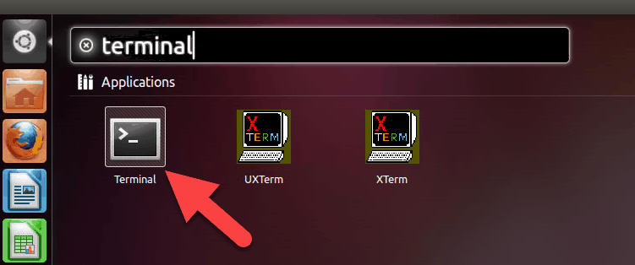

2. Make sure to update the package repository cache to ensure it installs the latest versions of the software. To do so, type in the following command:

sudo apt-get update

### Step 2: Install Apache

1. To install Apache, run the following command in the terminal:

sudo apt-get install apache2

Press **y**(yes) and hit **ENTER**to permit the installation.

2. Check if Apache is installed correctly by running the Apache service status. Use the following the command:

sudo service apache2 status

If everything installed correctly, you will receive this output:

Apache is active and running in Ubuntu.

3. Next, make sure that the **UFW firewall** has an application profile for Apache by typing in the following command:

sudo ufw app list

In the Apache Full profile, make sure it allows the traffic on ports **80** and **443**. Check this by typing the command:

sudo ufw app info “Apache Full”

You will see the output as in the following image:

4. To ensure Apache is running, enter the IP address of your server in the address bar and press **ENTER**.

The test Apache web server page should display as below.

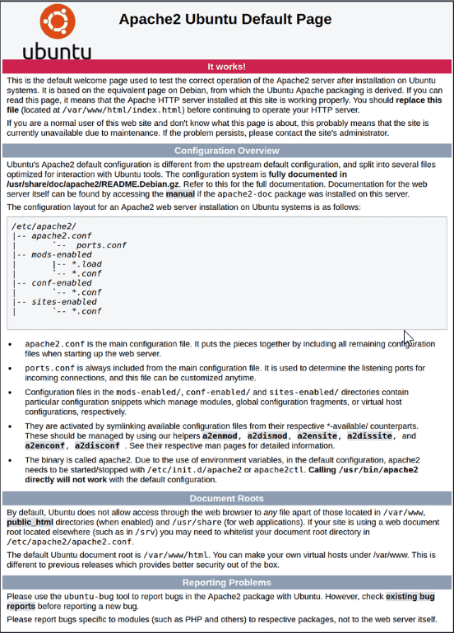

**Note:** To identify the server’s public IP address, run the command:

sudo apt-get install curl

curl http://icanhazip.com

### Step 3: Install MySQL and Create a Database

To install MySQL, type in the following command:

sudo apt-get install mysql-server

Press **y** to allow the installation.  
During the installation, you will be prompted to set the root user password.

**Note:** Although it is not mandatory to [set the root password](https://phoenixnap.com/kb/how-to-change-root-password-linux), it is recommended as a precautionary safety measure.

### Step 4: Install PHP

1. To install PHP, run the following command:

sudo apt-get install php libapache2-mod-php php-mysql

Press **y**and **ENTER** to allow the installation.

2. Next, you should modify the way Apache serves files when directories are requested. By default, Apache first looks for a file card named **index.html**. However, we want it to look for the **index.php** file instead.

To change this, open the **dir.conf** file in a text editor with root privileges:

sudo nano /etc/apache2/mods-enabled/dir.conf

In the configuration file, you will see the information as in the image below:

PHP directory index Ubuntu.

Then, move the PHP index file to the first position:

Change PHP index file position.

3. Press **CTRL + X**to save and close the file. Press **y** and **ENTER** to confirm.

### Step 5: Restart Apache

For the changes to take effect, you must restart the Apache service.

Enter the command:

sudo systemctl restart apache2

#### Optional: Install PHP Modules

You can add more modules to improve the functionality of PHP. You can search through a variety of libraries and modules by piping (listing in chunks) the results of the apt-cache search into **less**, allowing to scroll through the output of other commands.

1.  Type in the following command:

apt-cache search php- | less

2. Once you open it, scroll up and down by using the arrow keys to see all the options, including a short description for each module.

For example, to find out what the module **php-cli**does, type:

apt-cache show php-cli

This command displays the description of the module. If you decide to install the package after viewing its description, you can do so by using the following command:

sudo apt-get install php-cli

3. When you finish, press **q** to quit.

### Step 6: Test PHP Processing on Web Server

1. Create a basic **PHP script** and save it to the “web root” directory. This is necessary for Apache to find and serve the file correctly. This directory is located at **/var/www/html/**.

To create a file in that directory, type in the following command:

sudo nano /var/www/html/info.php

This command opens the **bank file**.

2. Inside the file, type in the valid PHP code:

<?php

phpinfo ();

?>

3. Press **CTRL + X** to save and close the file. Press **y** and **ENTER** to confirm.

4. Open a browser and type in your **IP address/info.php**  
The output should display the details of the [LAMP stack](https://phoenixnap.com/kb/what-is-a-lamp-stack), as seen in the image below:

Step 7: Host WORDPRESS

1)Open browser and go to https://wordpress.org/latest.zip

2)Copy the link address and open terminal

3)Install wget (if not installed) -> sudo apt install wget

wget (paste the copied link address)

4)Install unzip (if not installed) -> sudo apt install unzip

5)Go to wordpress directory

cd wordpress/

6)Copy all the files in wordpress recursively

sudo cp –r * /var/www/html

cd /var/www/html

7)Remove one file name “index.html”

sudo rm –rf index.html

8)Change permission(ownership) of the files

sudo chmod –R www-data:www-data /var/www/

9)Open browser and type localhost

10)WordPress window will be opened -> successful installation

11)Select English Language and continue

12)Set database Connection details :

13)Open terminal

sudo mysql –u root –p

(Enter password of database)

⮚ create database [databasename];

⮚ create user “[username]” identified by “[password]”;

⮚ grant all privileges on [databasename].* to “[username]”;

⮚ exit

Database Name : [databasename]

Username : [username]

Password : [password]

Database Host : localhost

Table Prefix : wp_